*Subject: Grow your investments. Reduce your taxes.*

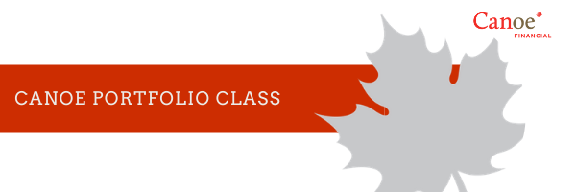

**Helping you help your clients with tax efficient investment solutions**

**Canoe Portfolio Class** is an innovative solution that provides tax efficient growth and income for your clients’ non-registered investments.

***Canoe Portfolio Class,* through its unique structure, provides:**

* *Tax efficient income:* pooling of income and expenses reduces overall income that is distributed and taxed in the hands of your clients. Additionally, a taxable disposition is only triggered when they reduce or fully redeem their investment in Canoe Portfolio Class.
* *Tax deferred growth:* paying less tax now leaves more of your clients’ assets at work to compound over time.
* *No “trapped Income”:* utilizing a trust component allows any excess income to flow to investors which avoids a tax charge against the investment’s NAV.
* *Tax-free switching:* your clients can switch between Canoe Portfolio Class Funds without triggering a taxable event.

**Additional materials (click to download PDF)**

|  |  |  |
| --- | --- | --- |
| [**Overview**](http://bit.ly/2JNcqr8) | [**Mechanics**](http://bit.ly/2Cx34jO) | [**Canoe Portfolio Class line up**](http://bit.ly/2IN82ad) |
|  |  |  |

Contact your Canoe Representative to learn more.

|  |  |  |  |
| --- | --- | --- | --- |
| **Calgary Office** 421 – 7th Avenue SW, Suite 2750 Calgary, Alberta T2P 4K9 | **Toronto Office** 1 Adelaide Street E, Suite 2410 Toronto, ON M5C 2V9 | **Montréal Office** 600 boul de Maisonneuve O, Suite 1620 Montréal, QC H3A 3J2 | |
| **[canoefinancial.com](http://www.canoefinancial.com/)** | [**LinkedIn**](https://www.linkedin.com/company/canoe-financial) |  | **[Twitter](http://www.twitter.com/canoefinancial)** |

Commissions, trailing commissions, management fees and expenses all may be associated with mutual fund investments. Please read the prospectus before investing. The indicated rates of return are the historical annual compounded total returns including changes in unit value and reinvestment of all distributions and do not take into account sales, redemption, distribution or optional charges or income taxes payable by any unitholder that would have reduced returns. The indices cited are widely accepted benchmarks for investment performance within their relevant regions, sectors or asset class, represent non-managed investment portfolios, and are not necessarily indicative of future investment returns. Mutual funds are not guaranteed, their values change frequently and past performance may not be repeated. This communication is for informational purposes only and is not intended to provide specific financial, investment, tax, legal, accounting or other advice to you, and should not be acted or relied upon in that regard without seeking the advice of a professional. The information contained in this presentation should not be considered as personal investment advice or as a public offering to sell, or a solicitation of an offer to buy securities. Investors should consult their Investment Advisor for complete details and risk factors on specific strategies and various investment products, prior to making any investment decisions. Each Portfolio Class Fund consists of an investment in shares of a Corporate Class Fund and a trust unit of the Canoe Trust Fund. Please see the prospectus for details.